Assignment 4:

Perform Health Checks and Remedy Issues

Step 1: Conduct a health check on your test environment

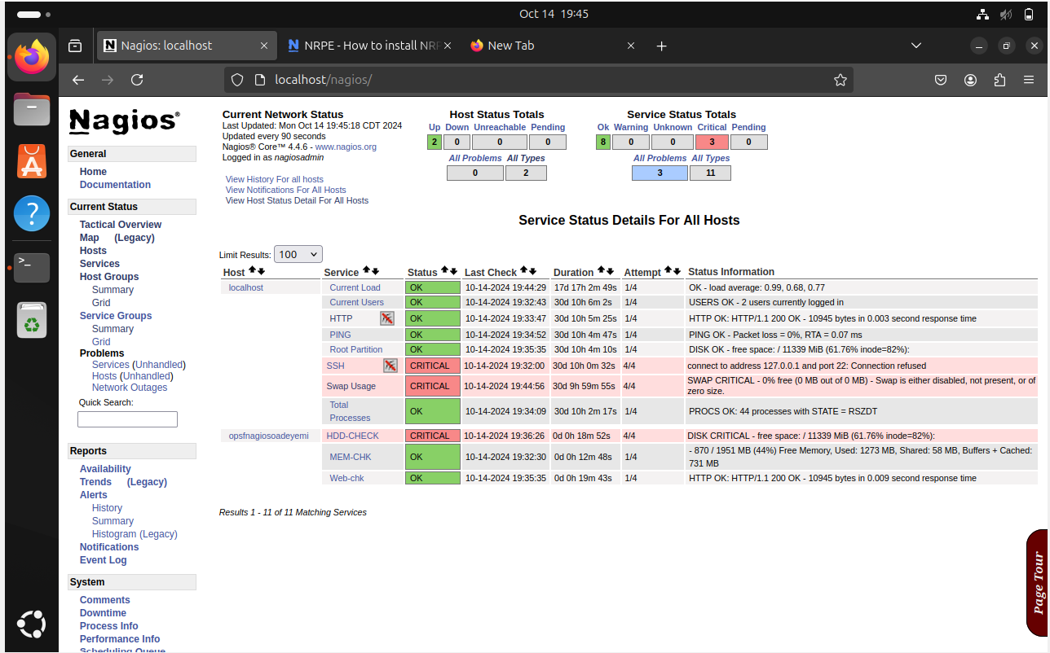

Incident Report

Ticket Number: INC-00378

Client Name: [Chris Clarke]

Date: [15/10/2024]

Summary: Disk Space critically low on Host oadeyemiopsf

SLA TYPE: LEVEL 2 (Basic)

Number affected users: 1

Description of the Issue: A critical alert about the disk space on the Nagios host was raised by the Nagios monitoring system. The disk's available space is critically low, according to the HDD-CHECK service, with only 11,339 MB of free space left after 61.76% inode usage. This warning suggests that the system may run out of storage, which could result in logging errors, service outages, or the inability to store important data. Considering the virtual machine environment, this problem needs to be fixed immediately to stop additional system issues.

Step 2: Create your change request to remedy this issue

Change Request

Ticket Number: CHR-00034

Requested By: [Oluwafemi Adeyemi]

Date: [15/10/2024]

Summary: increasing hard disk capacity

Change Request Type: Normal

Number affected users: 1

summary: This change request suggests increasing the disk space on the Nagios host virtual machine by an additional GB. This change is necessary to resolve a Critical HDD-CHECK alert, which shows the system is running low on disk space. expanding the disk capacity will result in system stability or the ability to store important data potentially avoiding monitoring failure.

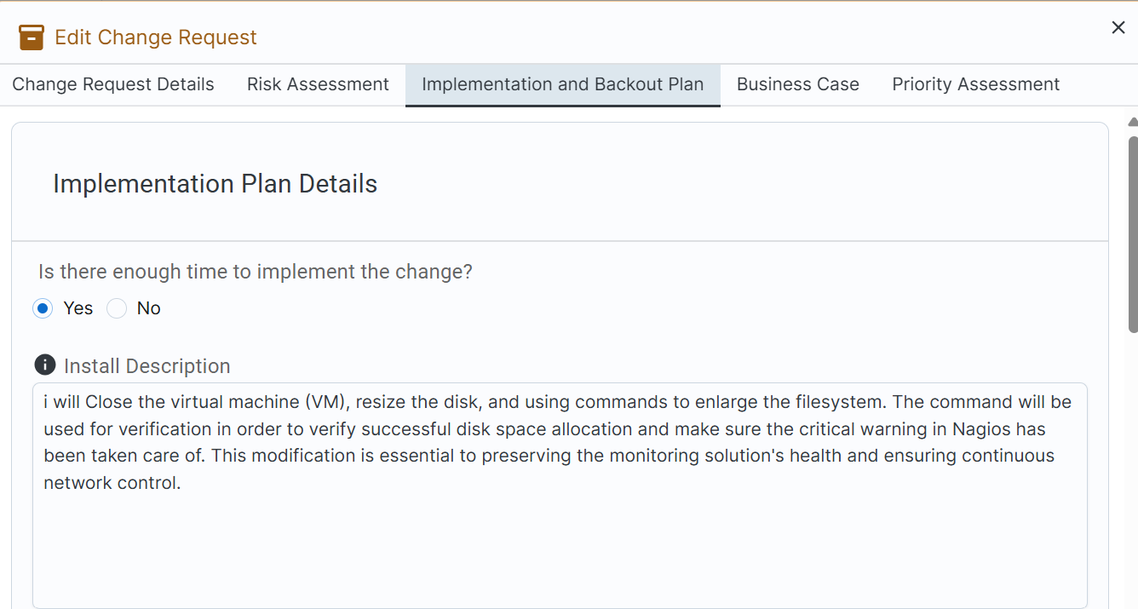

Health Check Report for Nagios Monitoring System

To: Michael Arnold (Instructor)

From: Oluwafemi Adeyemi

Date: October 14, 2024

Subject: Health Check Report on Disk Monitoring on Host oadeyemiopsf

Health Check Timing

Date of Health Check: October 14, 2024

Time: 19:56:17

Health Check Results

During the health check on the Nagios monitoring system, I reviewed the disk usage status for the host oadeyemiopsf. The system reported:

The Nagios monitoring host reported several critical issues, particularly related to disk space:

HDD-CHECK Status: Critical

Disk Space Available: Approximately 11 GB free

Inode Usage: 61.76%

Service: Hard disk

Status: OK

Free Disk Space: 11,335 MiB (61.74%)

**Remediation Steps Taken**

To address the critical disk space issue, the following steps were undertaken:

**Incident Report Creation:** An incident was logged in the ITSM tool to document the disk space issue, categorized as critical.

**Change Request Submitted:** A change request was created to expand the disk space to an additional GB on the system.

**Disk Space Expansion Implementation:**

The system was powered down.

Disk space was expanded.

The system was powered back on.

**Results post-change**

After implementing the disk space expansion, a follow up health check was done, and the results confirmed that the critical alert for disk space had been resolved. The available disk space has been successfully rectified, eliminating the previous critical warning.

